**DAILY ONLINE ACTIVITIES SUMMARY**

|  |  |  |  |  |  |  |  |  |
| --- | --- | --- | --- | --- | --- | --- | --- | --- |
| **Date:** | **01/07/2020** | | | | | **Name:** | **Lavanya D M** | |
| **Sem & Sec** | **4th & ‘A’** | | | | | **USN:** | **4al18cs041** | |
| **Online Test Summary** | | | | | | | | |
| **Subject** | | **----** | | | | | | |
| **Max. Marks** | | **----** | | **Score** | | | **-----** | |
| **Certification Course Summary** | | | | | | | | |
| **Course** | EIGRP Course | | | | | | | |
| **Certificate Provider** | | | **Bitdegree** | | **Duration** | | | **1week** |
| **Coding Challenges** | | | | | | | | |
| **Problem Statement:**  1) Given two lists, sort the values of one list using the second list  2) C++ program for Banking Management System using Class | | | | | | | | |
| **Status: Complied** | | | | | | | | |
| **Uploaded the report in Github** | | | | | **yes** | | | |
| **If yes Repository name** | | | | | <https://github.com/lavanyamurthi/lockdown-coding> | | | |
| **Uploaded the report in slack** | | | | | **yes** | | | |

Online Test Details: (Attach the snapshot and briefly write the report for the same)

No test conducted

Webinar:

Today class is conducted on C Programming by Megha ma’am in which we learn about the concept of C Programming, and even we had quiz regarding that

Certification Course Details: (Attach the snapshot and briefly write the report for the same)

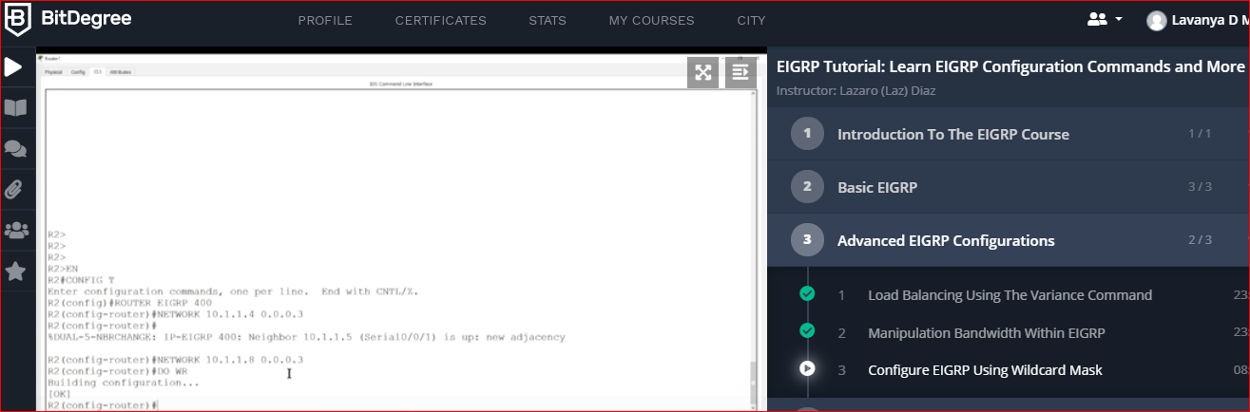

Coding Challenges Details: (Attach the snapshot and briefly write the report for the same)

**Problem 1**

Given two lists, sort the values of one list using the second list

Examples:  
Input :  
list1 = ["a", "b", "c", "d", "e", "f", "g", "h", "i"] list2 = [ 0, 1, 1, 0, 1, 2, 2, 0, 1]  
Output :  
['a', 'd', 'h', 'b', 'c', 'e', 'i', 'f', 'g'] Input : list1 = ["g", "e", "e", "k", "s", "f", "o", "r", "g", "e", "e", "k", "s"] list2 = [ 0, 1, 1, 0, 1, 2, 2, 0, 1] Output : ['g', 'k', 'r', 'e', 'e', 'g', 's', 'f', 'o']

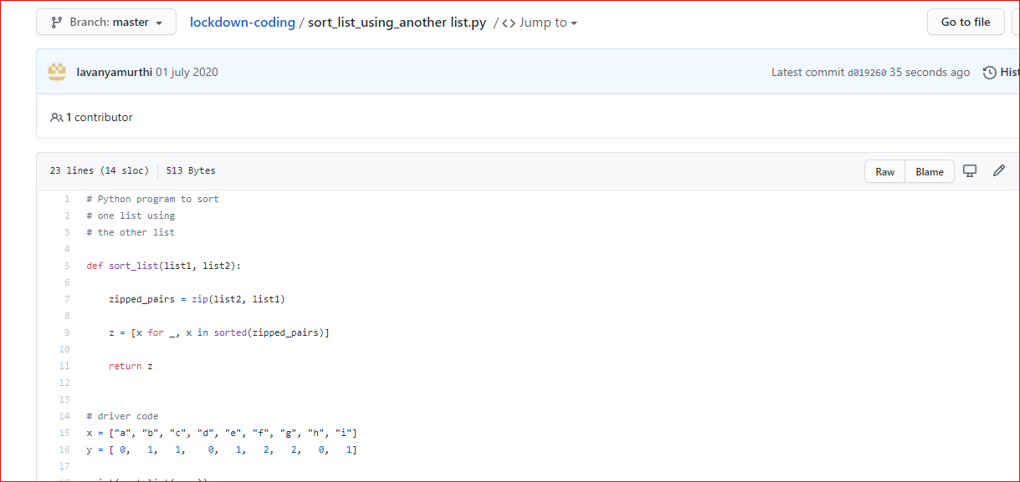

|  |
| --- |
|  |
|  |  |

# **Problem 2:**  **C++ program for Banking Management System using Class**

